Claudio Hernandez
Brian Arias
Database Management Project Part 1
Alex Liew

Social media platform

To create a comprehensive social media platform, we need a database system that can manage user profiles, content creation, social interactions, and community engagement. Users will create profiles that include essential information such as username, location, and privacy settings. This data will allow users to personalize their profiles while controlling the visibility of their content. Posts will be a primary content type, allowing users to share various media types (text, images, videos) with timestamps and location tags.
Each post should include visibility settings to define if it’s public, friends-only, or private. This will allow users to curate their online presence and engage selectively within the platform.
Social interactions will be at the core of the platform, enhancing user engagement through links, comments, and friend connections. The database should store details for each interaction, including user likes and comments on posts, allowing us to track engagement levels for each post. The friendship functionality will allow users to send, accept, or decline friend requests, with a status field to indicate pending, accepted, or blocked requests. In addition, the platform should support private messaging between users, storing message content, timestamps, and read/unread status to facilitate real-time communication. Notifications will play a critical role in alerting users about new friend requests, messages, likes, and comments, enhance engagement by keeping users informed.
To promote a sense of community, the platform will include groups that users can join to discuss specific topics or interests. Each group will have its privacy settings, allowing it to be public, private, or invitation-only. Group memberships should record each member’s role, such as admin or member, to manage permissions for posting and moderation within the group. The platform will also allow users to follow other users or pages, creating a more flexible network structure where users can choose to follow content without establishing a friend connection. These features will allow the database to handle diverse types of
user interactions and ensure a scalable, efficient platform.

Table of Contents
Entity Identification and attribute definition(Brian Arias) 3
Main entities Tables 3
Interaction & Relationship Tables 4
The Messaging & Group System 4
ER diagrams(Claudio Hernandez) 6
Users,posts, comments, likes, and groups diagram. 7
User to Posts, likes comments and groups Relationships 8
Users to Users Relationship (Following and friend requests) Diagram 9
Relationships User to User. 10
Users between Chats, Messages, and notifications diagram. 10
Users Relationships between Chats, Messages, and notifications. 10
Assumptions and design process. 11

Entity Identification and attribute definition(Brian Arias)

PK = Primary Key
FK = Foreign Key

Main entities Tables
Users Table
- User_ID (PK)
- Username
- First_Name
- Last_Name
- Email
- Date_Of_Birth
- Phone
- Location
- Privacy_Setting
- Date_Joined
- User_Type
Posts Table
- Post_ID (PK)
- User_ID (FK)
- Title
- Content
- Post_Date
- Post_Type
- Location_Tag
- Visibility_Setting
- Group_ID (nullable)
Comments Table
- Comment_ID
- Post_ID (FK)
- User_ID (FK)
- Comment_Text
- Comment_Date

Interaction & Relationship Tables
Follows Table (Unary Relationship)
- Follower_ID (PK, FK): (References User_ID) -> Composite primary key
- Followee_ID (PK, FK): INT (User_ID)
- Follow_Date
Likes Table
- User_ID (PK, FK): INT (References User_ID)
- Post_ID (PK, FK): INT (References Post_ID)
- Liked_At: TIMESTAMP

The Messaging & Group System
FriendShips Table
- Requester_ID (PK,FK)
- Addressee (PK,FK)
- Status
- Updated_At
Groups Table
- Group_ID (PK)
- Group_Name
- Description
- Privacy_Setting
Group_Members Table (M:N Relationship)
- Group_ID (PK, FK
- User_ID (PK, FK)
- Joined_At
- Role
Notification Table
- Notification_ID
- User_ID
- Notification_Type
- Content
- Is_Read
- Created_At
Chats
- Chat_ID
- Created_AT
Chat_Participants
- Chat_ID(PK,FK)
- User_ID(PK,FK)
- Joined_At
Messages Table
- Message_ID (PK)
- Sender_ID (FK)
- Chat_ID (FK)
- Message_Text
- Sent_Date
- Status (ex: sent, delivered, read)

ER diagrams(Claudio Hernandez)

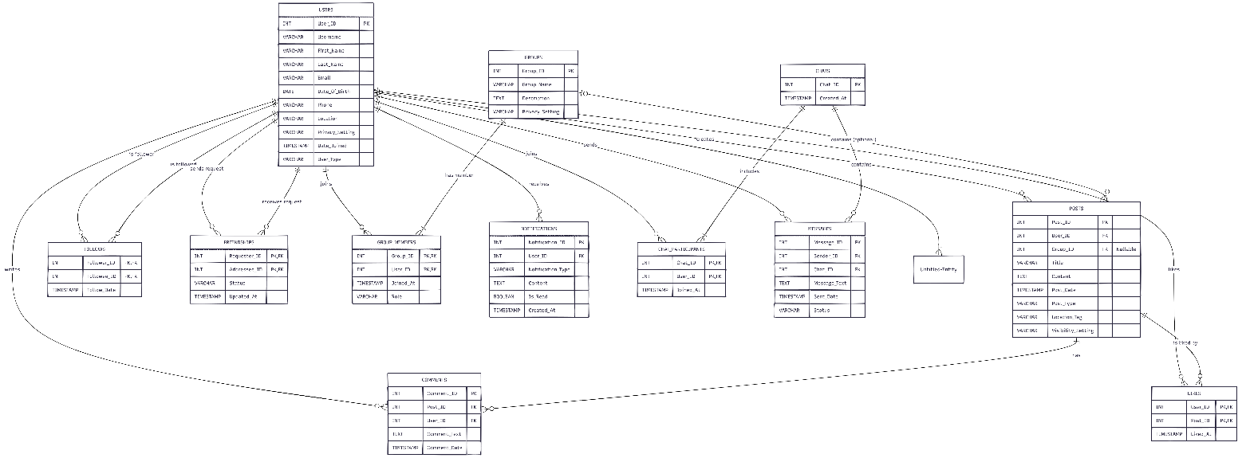

For better visualization we have broken down each section of the app.

Users,posts, comments, likes, and groups diagram.
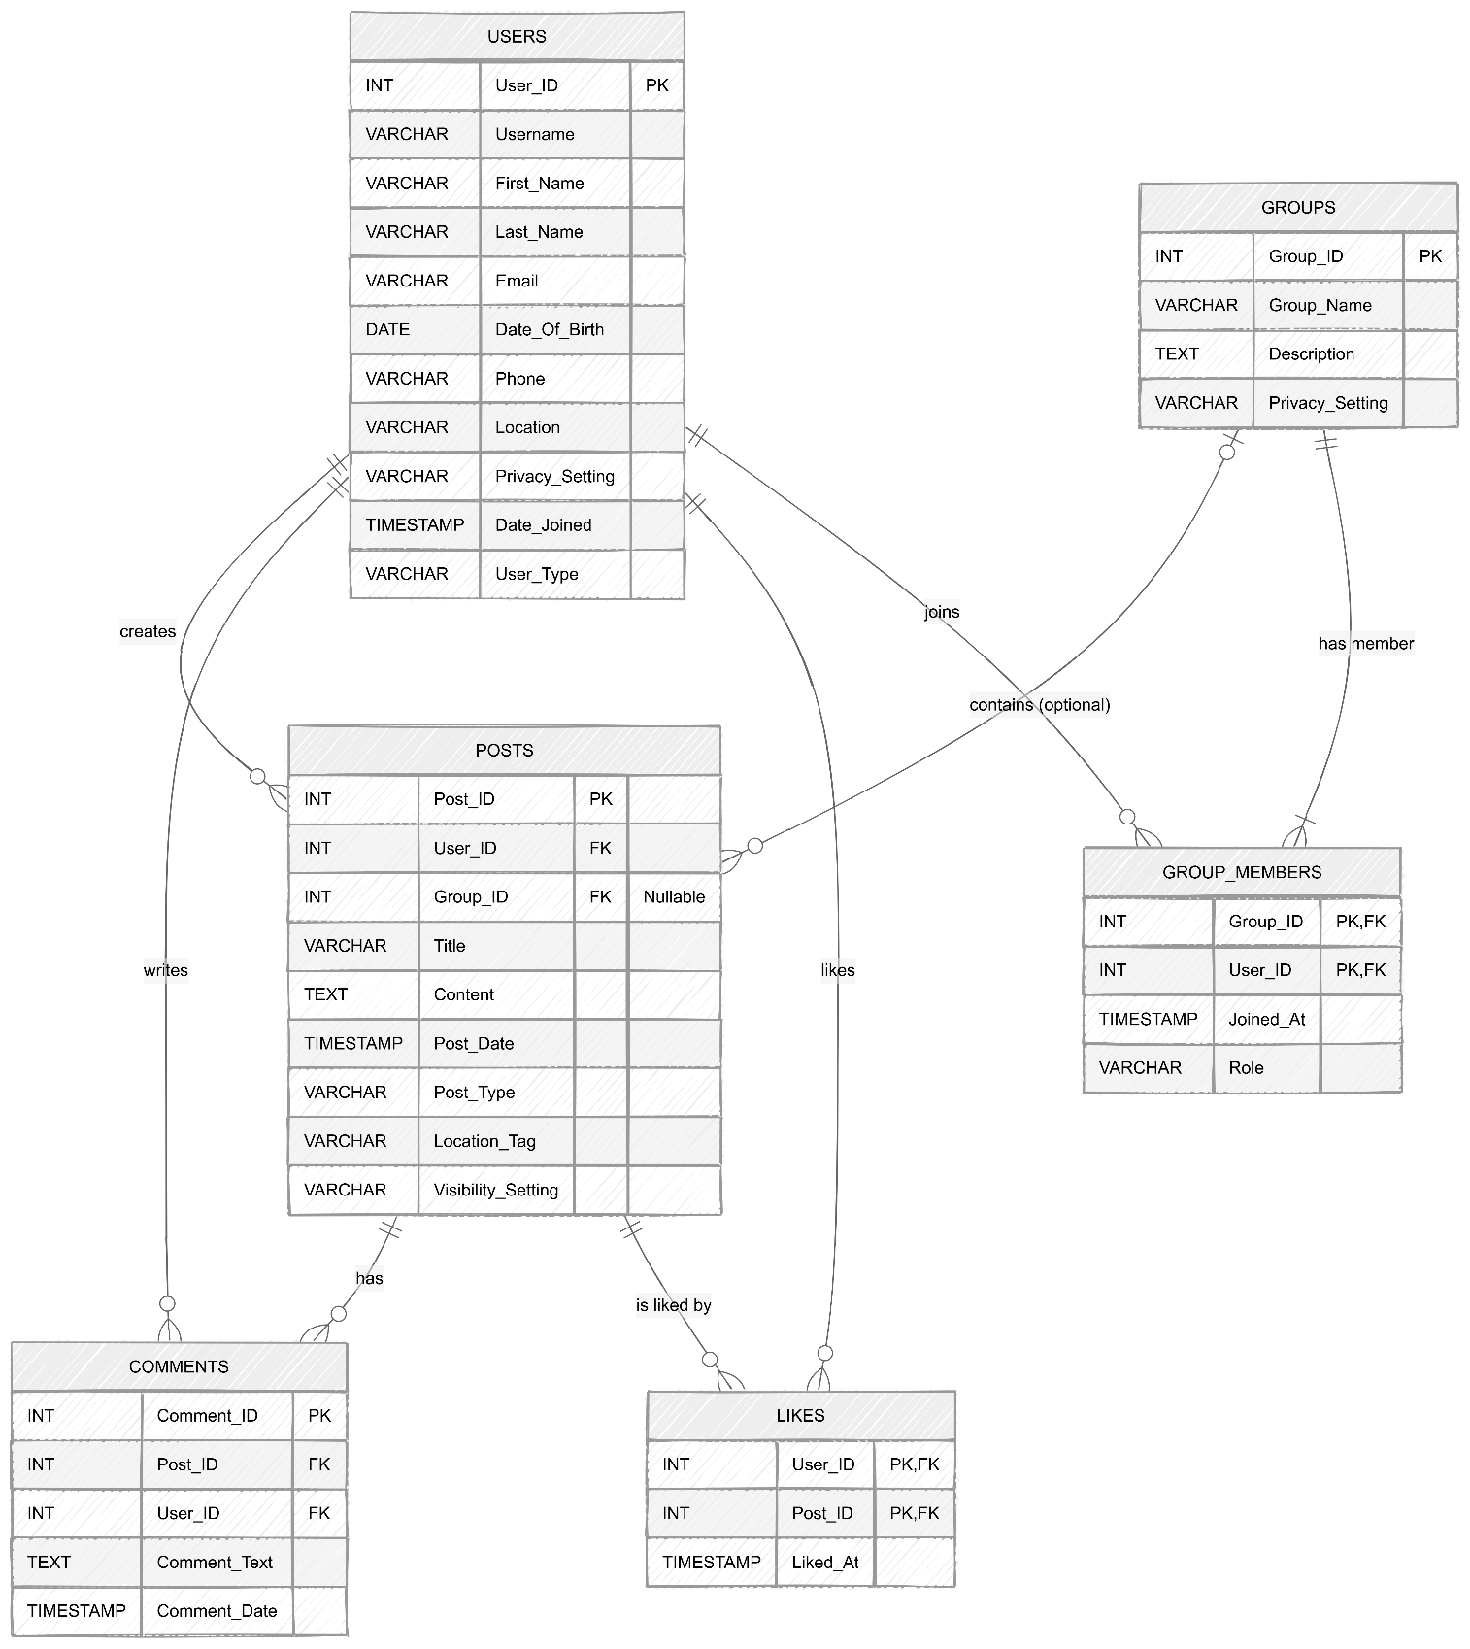

User to Posts, likes comments and groups Relationships
- Users to Posts (1: N)
- Cardinality: 1 User can create N (many) Posts. 1 Post belongs to exactly 1 User.
- Participation: Partial for Users (a user doesn't have to post), but Total for Posts (every post must be linked to a user).
- Users to Comments (1: N) & Posts to Comments (1: N)
- Cardinality: 1 User can write N Comments. 1 Post can have N Comments.
- Participation: Partial for Users/Posts, Total for Comments (a comment cannot exist without an author and a parent post).
- Users to Posts: Likes (M: N)
- Cardinality: N Users can like M Posts.
- Participation: Partial for both Users and Posts. Resolved by the Likes junction table.
- Users to Groups (M: N)
- Cardinality: N Users can join M Groups.
- Participation: Partial for Users (don't have to join groups), Total for Groups (a group usually must have at least one creator/member). Resolved by the Group_Members junction table.
- Users to Group_Members & Groups to Group_Members (Two 1: N Relationships)
- Cardinality: 1 User can have N Group_Members records (by joining multiple groups). 1 Group can have N Group_Members records (by having multiple users).
- Participation: Users side: Partial (a user doesn't have to join a group).
  - Groups side: Total (a group must have at least one member/creator to exist).
  - Group_Members side: Total for both (a member record cannot exist without both a valid User ID and a valid Group ID)

Users to Users Relationship (Following and friend requests) Diagram
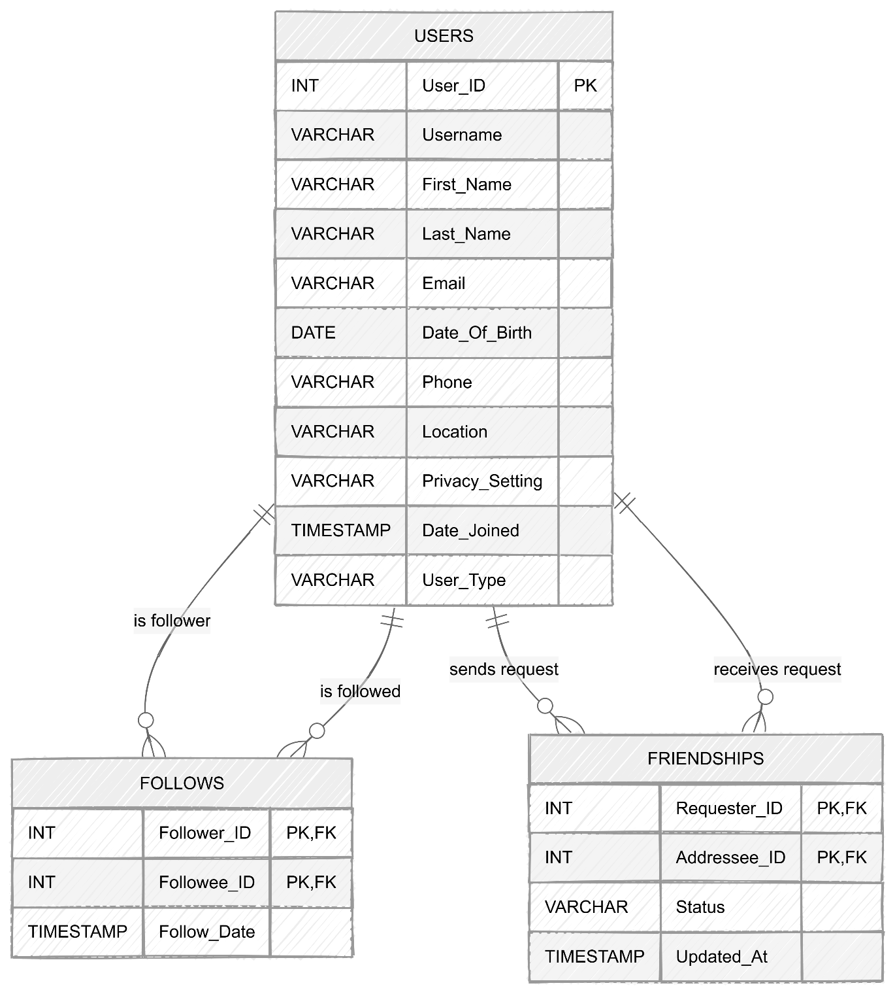

Relationships User to User.
- Users to Users: Follows & Friendships (M: N Unary)
  - Cardinality: N Users can follow/friend M Users.
  - Participation: Partial for both sides (users are not required to have followers or friends). This is solved by the Follows and FriendShips composite tables.

Users between Chats, Messages, and notifications diagram.
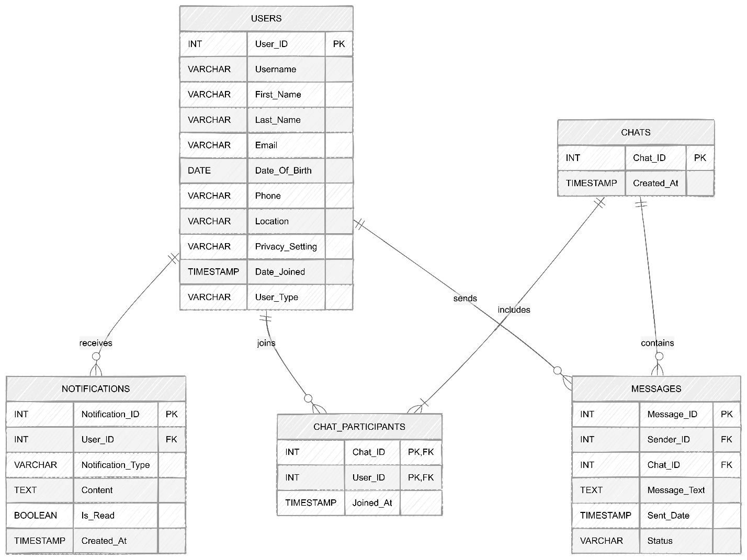

Users Relationships between Chats, Messages, and notifications.
- Chats to Users (M:N)
- Cardinality: N Users participate in M Chats.
- Participation: Partial for Users, Total for Chats. Resolved by the Chat_Participants table.
- Chats to Messages (1: N)
- Cardinality: 1 Chat contains N Messages.
- Participation: Total for Messages (a message must belong to a chat).
- Users to Notifications (1: N)
- Cardinality: 1 User can receive N (many) Notifications. 1 Notification belongs to exactly 1 User.
- Participation: Partial for Users (a user might have zero notifications if they are new), but Total for Notifications (a notification cannot exist in the void; it must be tied to a specific user to alert them).
- Users to Chat_Participants & Chats to Chat_Participants (Two 1: N Relationships)
- Cardinality: 1 User can have N Chat_Participants records (by being in multiple chats). 1 Chat can have N Chat_Participants records (by having multiple users in the room).
- Participation: Users side: Partial (a user doesn't have to be in any chats).
  - Chats side: Total (a chat room must have participants to be created).
  - Chat_Participants side: Total for both (a participant record cannot exist without both a valid User ID and a valid Chat ID).

Relational Algebra formulas
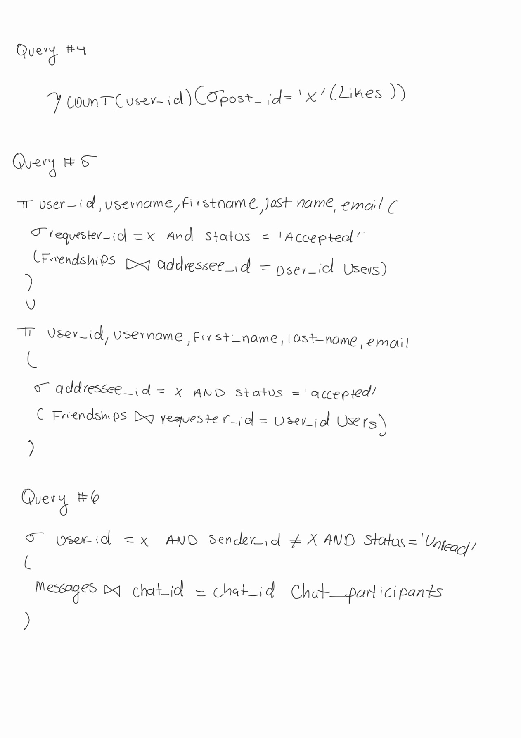

Why we use Chat implementations.
We decided to build our messaging system using CHATS, CHAT_PARTICIPANTS, and MESSAGES tables instead of just linking messages directly from a sender to a single receiver. We chose this design because it is much closer to how real-world apps work. By setting it up this way, our database can easily handle both private 1-on-1 conversations and large group chats without needing any future redesigns. It also makes it much faster and easier to load a user's "inbox" to show all their active conversations at once. Using this approach makes our database much more flexible and ready to grow as the platform gets more users.

Assumptions and design process.
We stumbled with some design assumptions and mistakes at the beginning due to experience working with document based databased that somewhat confused us. For instance, we assumed that Users would have an attribute containing a list of all groups joined, however that would have ignored the purpose of the relational database structure.
We assume and consider that a page is just a type of user that can post, as that way we can use user in a more scalable way, this way someone can like and follow a page just as a normal user.
Since posts can be submitted in a group, we have a nullable Group_ID attribute in posts, this is to distinguish if a post belongs to a post, or simply from a normal user.
We divided the design process into 3 parts. Both of us worked in the attributes and entities identification process. After, Claudio created some sketches for the ER diagram and then worked on the relationships of all entities. After having a complete roadmap of the relationships, we divided the ER diagram into sections for easier reading for Professor and future readability in the document; this way we can also isolate the closer relationships and make the ER diagram more meaningful.
Sources used:
https://www.geeksforgeeks.org/mysql/mysql-on-delete-cascade-constraint/https://www.w3schools.com/sql/sql_insert.asp
https://www.w3schools.com/sql/sql_create_table.asp

